**Hyperparameter tuning**

In MF we have one hyperparameter d (dimension) As shown below for matrix B and C we can take any d but it should be greater than 0 and smaller than m and n

So there are 2 ways for this

1. Problem specific/Task :

Suppose we want user and item information of 100 dimension then we can assign 100 to d

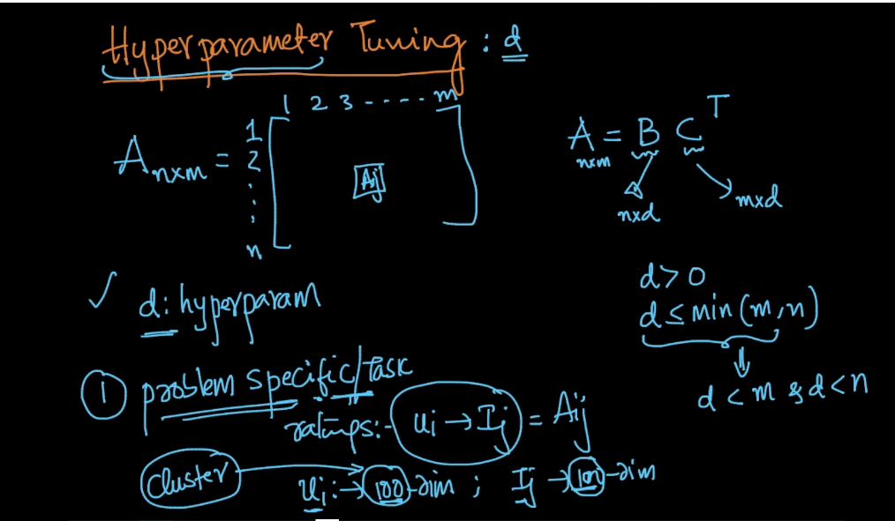

1. Systematic Way :

As we know optimization formulae

In this there is error part as shown below,

So as d increases, error decreases.

So for various d we run this and draw a graph on x-axis we take d and on y-axis we take error so as we see error is reducing very fast but at one point error starts reducing slowly this point is called inflection point in below this is at d = 10

Or we can say we take smallest d of slow slow error reducing graph

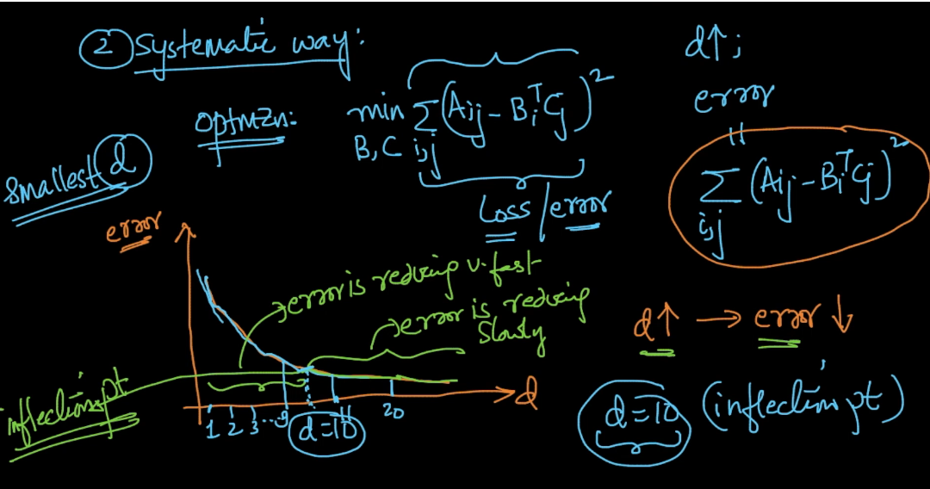

Another way in this only is taking gradient at point so initially gradient is high but slowly it starts reducing and we take smallest reducing point

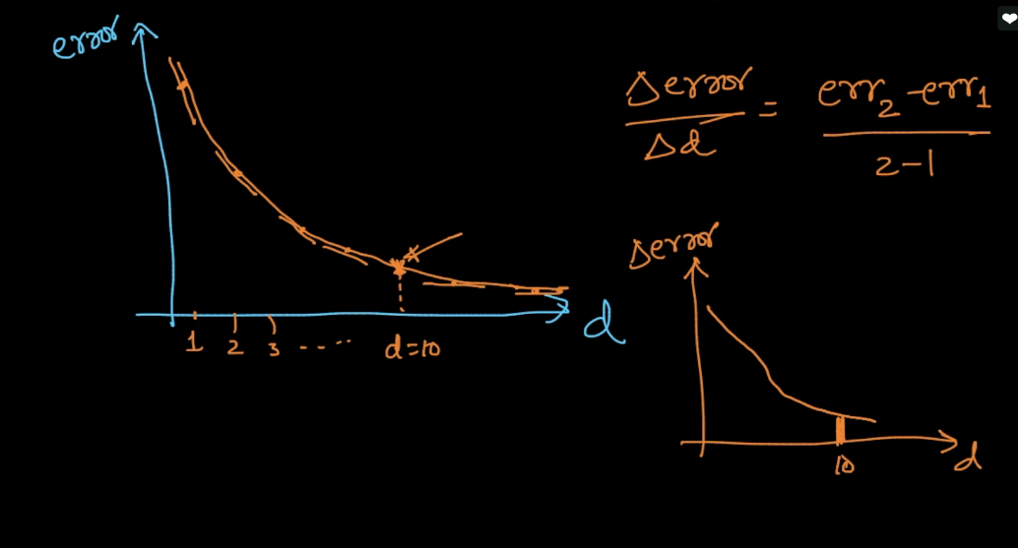

Comments :



